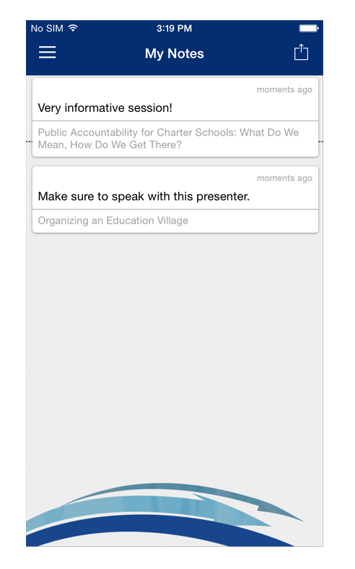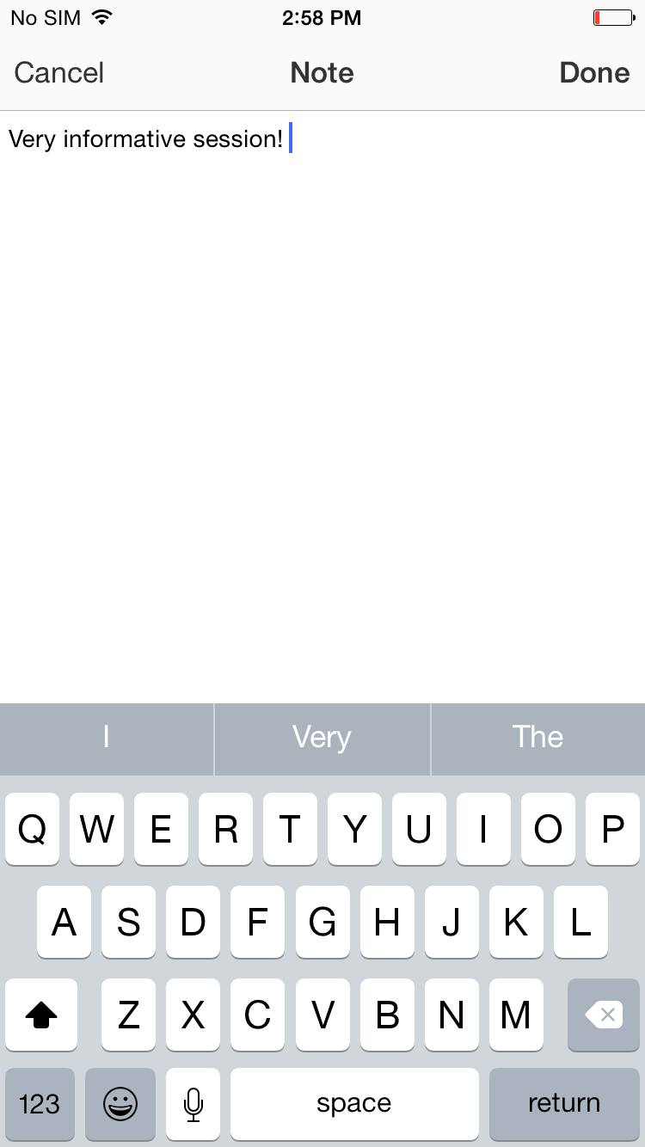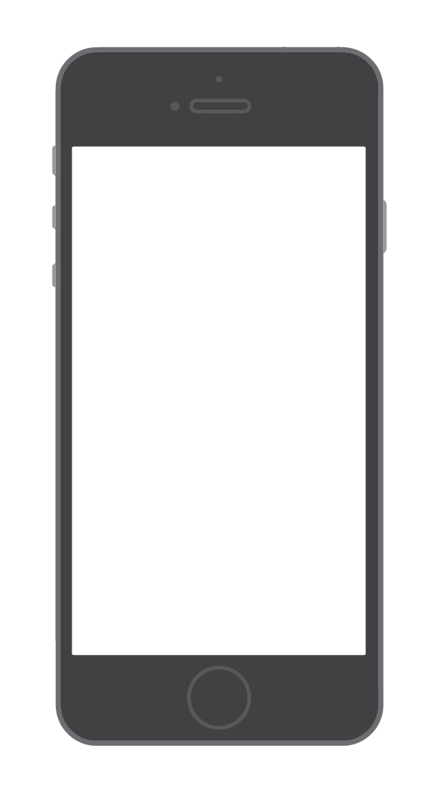

**1 Navigate to My Notes.** Tap the hamburger icon in the top right, then My Notes.

Here you’ll find all the notes you’ve taken organized by session.

**2 Choose where to send your notes.** Tap the share icon in the top right and the NORM app will automatically generate a draft of an email that contains all your notes. All you have to do is enter an email address, then tap **Send**.

**Email Them Out**

**Write Your Thoughts**

**1 Find your Event Item.** After logging in to the NORM Conference app, find the session, speaker or attendee you'd like to create a note about by tapping on the appropriate icon in the Event Directory, then scrolling through the item list.   
  
Once you've found the item you're looking for, tap on it.

**2 Write your note.** Tap the pencil icon to bring up a blank page and your keyboard. Enter your thoughts, observations and ideas. Tap **Done** when you've finished.

**Creating Notes**