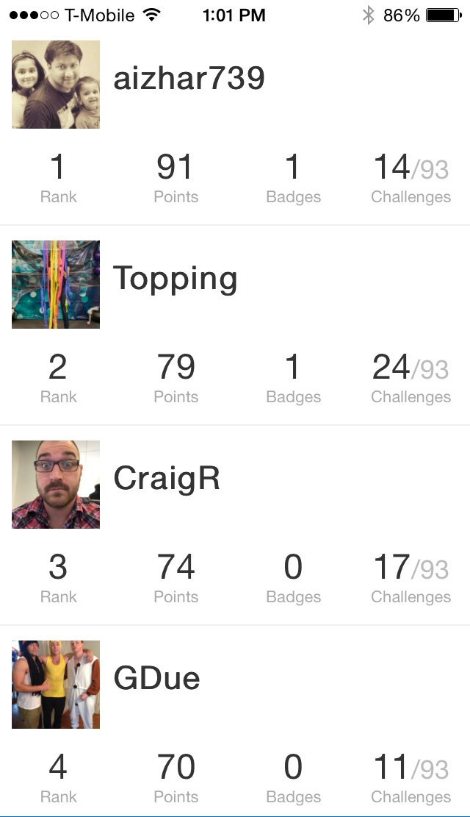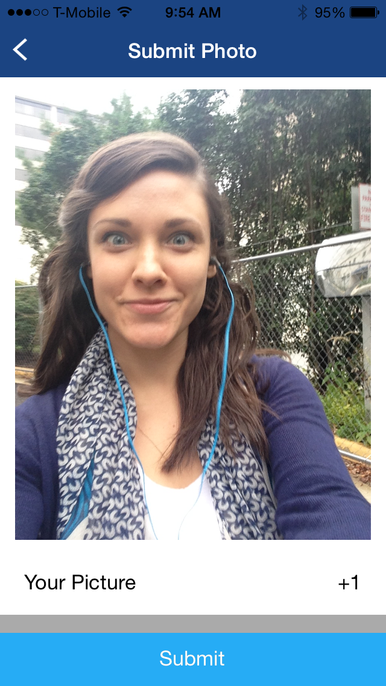** 

**1 See your friends.** Tap **Leaderboard** on the top left. You can follow along to see how they are enjoying the conference.

**2 Win the game.** Keep completing challenges to earn points. The more points you have, the higher your rank.

**Track the Competition**

**Snap to Win**

**1 Choose a challenge.** Tap **Profile** at the top right. Scroll down to see a list of badges and the challenges you need to complete to earn them. Take them on in any order!

**2 Submit a photo.** Tap the camera icon next to the challenge you want to take. Shoot or upload your masterpiece, then tap **Submit**.

**Playing Click**